Федеральное государственное образовательное бюджетное

учреждение высшего образования

**«Финансовый университет при Правительстве Российской Федерации»**

**(Финансовый университет)**

Колледж информатики и программирования

**ОТЧЕТ О ВЫПОЛНЕНИИ ЗАДАНИЯ № 7**

**Тема: Калькулятор**

Студент: Сергеева Анна Сергеевна

Группа: 3ПКС-420

Преподаватель: И.В. Сибирев

Дата: 24.11.2022

Москва 2022

**Цель работы:** Разработать калькулятор на языке С#. В проекте использовать прием создания одного обработчика для нескольких событий.

**Ниже на рисунке представлен фрагмент работающего проекта**

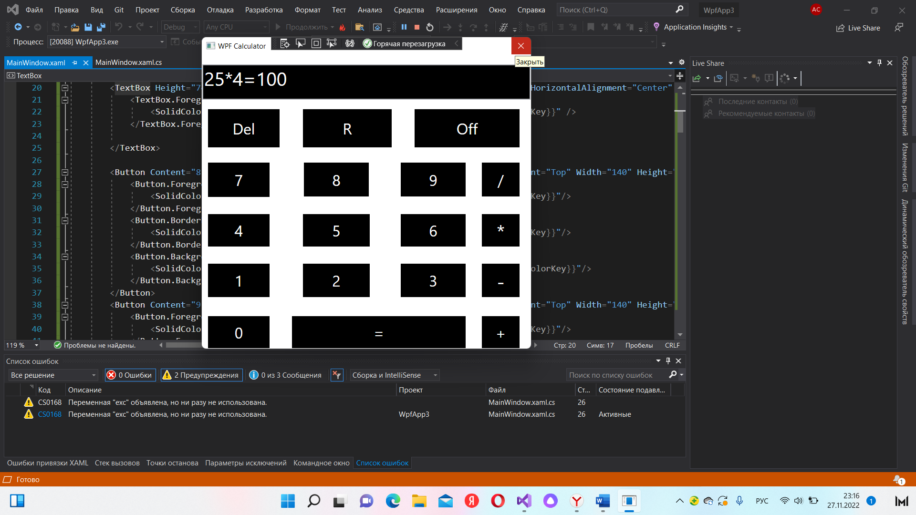

Рисунок 1. Калькулятор

**Код программы:**

using System;

using System.Windows;

using System.Windows.Controls;

namespace MyCalculatorv1

{

public partial class MainWindow : Window

{

public MainWindow()

{

InitializeComponent();

}

private void Button_Click_1(object sender, RoutedEventArgs e)

{

Button b = (Button)sender;

tb.Text += b.Content.ToString();

}

private void Result_click(object sender, RoutedEventArgs e)

{

try

{

result();

}

catch (Exception exc)

{

tb.Text = "Error!";

}

}

private void result()

{

String op;

int iOp = 0;

if (tb.Text.Contains("+"))

{

iOp = tb.Text.IndexOf("+");

}

else if (tb.Text.Contains("-"))

{

iOp = tb.Text.IndexOf("-");

}

else if (tb.Text.Contains("*"))

{

iOp = tb.Text.IndexOf("*");

}

else if (tb.Text.Contains("/"))

{

iOp = tb.Text.IndexOf("/");

}

else

{

//error

}

op = tb.Text.Substring(iOp, 1);

double op1 = Convert.ToDouble(tb.Text.Substring(0, iOp));

double op2 = Convert.ToDouble(tb.Text.Substring(iOp + 1, tb.Text.Length - iOp - 1));

if (op == "+")

{

tb.Text += "=" + (op1 + op2);

}

else if (op == "-")

{

tb.Text += "=" + (op1 - op2);

}

else if (op == "*")

{

tb.Text += "=" + (op1 * op2);

}

else

{

tb.Text += "=" + (op1 / op2);

}

}

private void Off_Click_1(object sender, RoutedEventArgs e)

{

Application.Current.Shutdown();

}

private void Del_Click(object sender, RoutedEventArgs e)

{

tb.Text = "";

}

private void R_Click(object sender, RoutedEventArgs e)

{

if (tb.Text.Length > 0)

{

tb.Text = tb.Text.Substring(0, tb.Text.Length - 1);

}

}

}

}

**Код WPF:**

<Window x:Class="MyCalculatorv1.MainWindow" xmlns="http://schemas.microsoft.com/winfx/2006/xaml/presentation" xmlns:x="http://schemas.microsoft.com/winfx/2006/xaml" Title="WPF Calculator" Height="663" Width="708" ResizeMode="NoResize" WindowStartupLocation="CenterScreen" Topmost="True">

<Grid Background="White" Height="653" VerticalAlignment="Top">

<Grid.RowDefinitions>

<RowDefinition/>

<RowDefinition Height="0*"/>

<RowDefinition Height="0*"/>

</Grid.RowDefinitions>

<Button Content="7" HorizontalAlignment="Left" Margin="11,224,0,0" VerticalAlignment="Top" Width="133" Height="75" FontSize="32" BorderThickness="2,2,2,1" Click="Button_Click_1">

<Button.Foreground>

<SolidColorBrush Color="{DynamicResource {x:Static SystemColors.WindowColorKey}}"/>

</Button.Foreground>

<Button.BorderBrush>

<SolidColorBrush Color="{DynamicResource {x:Static SystemColors.WindowColorKey}}"/>

</Button.BorderBrush>

<Button.Background>

<SolidColorBrush Color="{DynamicResource {x:Static SystemColors.WindowTextColorKey}}"/>

</Button.Background>

</Button>

<TextBox Height="74" TextWrapping="Wrap" VerticalAlignment="Top" Margin="0,20,0,0" HorizontalAlignment="Center" Width="688" FontSize="40" Background="Black" BorderThickness="2" Name="tb" Text="">

<TextBox.Foreground>

<SolidColorBrush Color="{DynamicResource {x:Static SystemColors.WindowColorKey}}" />

</TextBox.Foreground>

</TextBox>

<Button Content="8" HorizontalAlignment="Left" Margin="212,224,0,0" VerticalAlignment="Top" Width="140" Height="75" FontSize="32" BorderThickness="2" Click="Button_Click_1">

<Button.Foreground>

<SolidColorBrush Color="{DynamicResource {x:Static SystemColors.WindowColorKey}}"/>

</Button.Foreground>

<Button.BorderBrush>

<SolidColorBrush Color="{DynamicResource {x:Static SystemColors.WindowColorKey}}"/>

</Button.BorderBrush>

<Button.Background>

<SolidColorBrush Color="{DynamicResource {x:Static SystemColors.WindowTextColorKey}}"/>

</Button.Background>

</Button>

<Button Content="9" HorizontalAlignment="Left" Margin="415,224,0,0" VerticalAlignment="Top" Width="140" Height="75" FontSize="32" BorderThickness="2" Click="Button_Click_1">

<Button.Foreground>

<SolidColorBrush Color="{DynamicResource {x:Static SystemColors.WindowColorKey}}"/>

</Button.Foreground>

<Button.BorderBrush>

<SolidColorBrush Color="{DynamicResource {x:Static SystemColors.WindowColorKey}}"/>

</Button.BorderBrush>

<Button.Background>

<SolidColorBrush Color="{DynamicResource {x:Static SystemColors.WindowTextColorKey}}"/>

</Button.Background>

</Button>

<Button Content="/" HorizontalAlignment="Left" Margin="585,224,0,0" VerticalAlignment="Top" Width="83" Height="75" FontSize="32" BorderThickness="2" Click="Button_Click_1">

<Button.Foreground>

<SolidColorBrush Color="{DynamicResource {x:Static SystemColors.WindowColorKey}}"/>

</Button.Foreground>

<Button.BorderBrush>

<SolidColorBrush Color="{DynamicResource {x:Static SystemColors.WindowColorKey}}"/>

</Button.BorderBrush>

<Button.Background>

<SolidColorBrush Color="{DynamicResource {x:Static SystemColors.WindowTextColorKey}}"/>

</Button.Background>

</Button>

<Button Content="4" HorizontalAlignment="Left" Margin="11,332,0,0" VerticalAlignment="Top" Width="133" Height="72" FontSize="32" BorderThickness="2" Click="Button_Click_1">

<Button.Foreground>

<SolidColorBrush Color="{DynamicResource {x:Static SystemColors.WindowColorKey}}"/>

</Button.Foreground>

<Button.BorderBrush>

<SolidColorBrush Color="{DynamicResource {x:Static SystemColors.WindowColorKey}}"/>

</Button.BorderBrush>

<Button.Background>

<SolidColorBrush Color="{DynamicResource {x:Static SystemColors.WindowTextColorKey}}"/>

</Button.Background>

</Button>

<Button Content="5" HorizontalAlignment="Left" Margin="210,332,0,0" VerticalAlignment="Top" Width="144" Height="72" FontSize="32" BorderThickness="2" Click="Button_Click_1">

<Button.Foreground>

<SolidColorBrush Color="{DynamicResource {x:Static SystemColors.WindowColorKey}}"/>

</Button.Foreground>

<Button.BorderBrush>

<SolidColorBrush Color="{DynamicResource {x:Static SystemColors.WindowColorKey}}"/>

</Button.BorderBrush>

<Button.Background>

<SolidColorBrush Color="{DynamicResource {x:Static SystemColors.WindowTextColorKey}}"/>

</Button.Background>

</Button>

<Button Content="6" HorizontalAlignment="Left" Margin="415,332,0,0" VerticalAlignment="Top" Width="140" Height="72" FontSize="32" BorderThickness="2" Click="Button_Click_1" RenderTransformOrigin="0.524,0.607">

<Button.Foreground>

<SolidColorBrush Color="{DynamicResource {x:Static SystemColors.WindowColorKey}}"/>

</Button.Foreground>

<Button.BorderBrush>

<SolidColorBrush Color="{DynamicResource {x:Static SystemColors.WindowColorKey}}"/>

</Button.BorderBrush>

<Button.Background>

<SolidColorBrush Color="{DynamicResource {x:Static SystemColors.WindowTextColorKey}}"/>

</Button.Background>

</Button>

<Button Content="*" HorizontalAlignment="Left" Margin="585,332,0,0" VerticalAlignment="Top" Width="83" Height="72" FontSize="40" BorderThickness="2" Click="Button_Click_1">

<Button.Foreground>

<SolidColorBrush Color="{DynamicResource {x:Static SystemColors.WindowColorKey}}"/>

</Button.Foreground>

<Button.BorderBrush>

<SolidColorBrush Color="{DynamicResource {x:Static SystemColors.WindowColorKey}}"/>

</Button.BorderBrush>

<Button.Background>

<SolidColorBrush Color="{DynamicResource {x:Static SystemColors.WindowTextColorKey}}"/>

</Button.Background>

</Button>

<Button Content="1" HorizontalAlignment="Left" Margin="11,436,0,0" VerticalAlignment="Top" Width="133" Height="74" FontSize="32" BorderThickness="2" Click="Button_Click_1">

<Button.Foreground>

<SolidColorBrush Color="{DynamicResource {x:Static SystemColors.WindowColorKey}}"/>

</Button.Foreground>

<Button.BorderBrush>

<SolidColorBrush Color="{DynamicResource {x:Static SystemColors.WindowColorKey}}"/>

</Button.BorderBrush>

<Button.Background>

<SolidColorBrush Color="{DynamicResource {x:Static SystemColors.WindowTextColorKey}}"/>

</Button.Background>

</Button>

<Button Content="2" HorizontalAlignment="Left" Margin="210,436,0,0" VerticalAlignment="Top" Width="144" Height="74" FontSize="32" BorderThickness="2" Click="Button_Click_1">

<Button.Foreground>

<SolidColorBrush Color="{DynamicResource {x:Static SystemColors.WindowColorKey}}"/>

</Button.Foreground>

<Button.BorderBrush>

<SolidColorBrush Color="{DynamicResource {x:Static SystemColors.WindowColorKey}}"/>

</Button.BorderBrush>

<Button.Background>

<SolidColorBrush Color="{DynamicResource {x:Static SystemColors.WindowTextColorKey}}"/>

</Button.Background>

</Button>

<Button Content="3" HorizontalAlignment="Left" Margin="415,436,0,0" VerticalAlignment="Top" Width="140" Height="74" FontSize="32" BorderThickness="2" Click="Button_Click_1">

<Button.Foreground>

<SolidColorBrush Color="{DynamicResource {x:Static SystemColors.WindowColorKey}}"/>

</Button.Foreground>

<Button.BorderBrush>

<SolidColorBrush Color="{DynamicResource {x:Static SystemColors.WindowColorKey}}"/>

</Button.BorderBrush>

<Button.Background>

<SolidColorBrush Color="{DynamicResource {x:Static SystemColors.WindowTextColorKey}}"/>

</Button.Background>

</Button>

<Button Content="-" HorizontalAlignment="Left" Margin="585,436,0,0" VerticalAlignment="Top" Width="83" Height="74" FontSize="40" BorderThickness="2" Click="Button_Click_1">

<Button.Foreground>

<SolidColorBrush Color="{DynamicResource {x:Static SystemColors.WindowColorKey}}"/>

</Button.Foreground>

<Button.BorderBrush>

<SolidColorBrush Color="{DynamicResource {x:Static SystemColors.WindowColorKey}}"/>

</Button.BorderBrush>

<Button.Background>

<SolidColorBrush Color="{DynamicResource {x:Static SystemColors.WindowTextColorKey}}"/>

</Button.Background>

</Button>

<Button Content="0" HorizontalAlignment="Left" Margin="11,546,0,0" VerticalAlignment="Top" Width="133" Height="71" FontSize="32" BorderThickness="2" Click="Button_Click_1">

<Button.Foreground>

<SolidColorBrush Color="{DynamicResource {x:Static SystemColors.WindowColorKey}}"/>

</Button.Foreground>

<Button.BorderBrush>

<SolidColorBrush Color="{DynamicResource {x:Static SystemColors.WindowColorKey}}"/>

</Button.BorderBrush>

<Button.Background>

<SolidColorBrush Color="{DynamicResource {x:Static SystemColors.WindowTextColorKey}}"/>

</Button.Background>

</Button>

<Button Content="=" HorizontalAlignment="Left" Margin="187,546,0,0" VerticalAlignment="Top" Width="368" Height="71" FontSize="32" BorderThickness="2" Click="Result_click">

<Button.Foreground>

<SolidColorBrush Color="{DynamicResource {x:Static SystemColors.WindowColorKey}}"/>

</Button.Foreground>

<Button.BorderBrush>

<SolidColorBrush Color="{DynamicResource {x:Static SystemColors.WindowColorKey}}"/>

</Button.BorderBrush>

<Button.Background>

<SolidColorBrush Color="{DynamicResource {x:Static SystemColors.WindowTextColorKey}}"/>

</Button.Background>

</Button>

<Button Content="+" HorizontalAlignment="Left" Margin="585,546,0,0" VerticalAlignment="Top" Width="83" Height="71" FontSize="32" BorderThickness="2" Click="Button_Click_1">

<Button.Foreground>

<SolidColorBrush Color="{DynamicResource {x:Static SystemColors.WindowColorKey}}"/>

</Button.Foreground>

<Button.BorderBrush>

<SolidColorBrush Color="{DynamicResource {x:Static SystemColors.WindowColorKey}}"/>

</Button.BorderBrush>

<Button.Background>

<SolidColorBrush Color="{DynamicResource {x:Static SystemColors.WindowTextColorKey}}"/>

</Button.Background>

</Button>

<Button Content="Off" HorizontalAlignment="Left" Margin="444,112,0,0" VerticalAlignment="Top" Width="224" Height="84" FontSize="32" BorderThickness="2" Click="Off_Click_1">

<Button.Foreground>

<SolidColorBrush Color="{DynamicResource {x:Static SystemColors.WindowColorKey}}"/>

</Button.Foreground>

<Button.BorderBrush>

<SolidColorBrush Color="{DynamicResource {x:Static SystemColors.WindowColorKey}}"/>

</Button.BorderBrush>

<Button.Background>

<SolidColorBrush Color="{DynamicResource {x:Static SystemColors.WindowTextColorKey}}"/>

</Button.Background>

</Button>

<Button Content="Del" HorizontalAlignment="Left" Margin="11,112,0,0" VerticalAlignment="Top" Width="154" Height="84" FontSize="32" BorderThickness="2" Click="Del_Click">

<Button.Foreground>

<SolidColorBrush Color="{DynamicResource {x:Static SystemColors.WindowColorKey}}"/>

</Button.Foreground>

<Button.BorderBrush>

<SolidColorBrush Color="{DynamicResource {x:Static SystemColors.WindowColorKey}}"/>

</Button.BorderBrush>

<Button.Background>

<SolidColorBrush Color="{DynamicResource {x:Static SystemColors.WindowTextColorKey}}"/>

</Button.Background>

</Button>

<Button Content="R" HorizontalAlignment="Left" Margin="210,112,0,0" VerticalAlignment="Top" Width="190" Height="84" FontSize="32" BorderThickness="2" Click="R_Click">

<Button.Foreground>

<SolidColorBrush Color="{DynamicResource {x:Static SystemColors.WindowColorKey}}"/>

</Button.Foreground>

<Button.BorderBrush>

<SolidColorBrush Color="{DynamicResource {x:Static SystemColors.WindowColorKey}}"/>

</Button.BorderBrush>

<Button.Background>

<SolidColorBrush Color="{DynamicResource {x:Static SystemColors.WindowTextColorKey}}"/>

</Button.Background>

</Button>

</Grid>

</Window>